课程名称＿＿＿＿＿＿＿ 实验名称＿＿＿＿＿＿＿ 实验日期＿＿＿＿＿＿＿
班 级＿＿＿＿＿＿＿ 姓 名＿＿＿＿＿＿＿ 学号＿＿＿＿＿＿＿ 仪器编号＿＿＿＿＿＿
实验报告要求 1.实验目的 2.实验要求 3.实验步骤 4.程序清单 5.运行情况 6.流程图 7.实验体会
实验目的：
⑴ 熟悉树的定义和基本操
⑵ 掌握树的孩子兄弟链式存储结构设计与基本操作的实现

实验内容：
1、采用书上第 136 页定义的树的孩子兄弟存储表示，编写递归算法实现树的下列基本操作。
（1）构造树
（2）复制树
（3）销毁树
（4）清空树
（5）先根遍历树
（6）后根遍历树
（7）求树的深度
（8）求树的叶子节点数
2、采用书上第 136 页定义的树的孩子兄弟存储表示，编写非递归算法实现树的下列基本操作。
（1）构造树
（2）先根遍历树
（3）后根遍历树
（4）层次遍历树
（5）求树的深度
（6）统计树的结点数
（7）求树的叶子节点数

程序清单：
1.
#include<stdio.h>
#include<malloc.h>
#include<stdlib.h>
#define OK 1
#define ERROR 0
#define FALSE 0
#define TRUE 1
#define OVERFLOW -2
typedef int Status;
typedef char ElemType;
typedef struct CSNode
{
ElemType data;
struct CSNode *firstchild,*nextsibling;
}CSNode,*CSTree;
int Nodenum=0;//统计树的节点个数
int Count=0;//统计树中叶子节点的个数

Status CreateCSTree(CSTree &T)
{
//算法6.4
//按先序次序输入树中节点的值（一个字符），#字符表示空树，
//构造二叉链表表示的树T
ElemType ch;
scanf("%c",&ch);
if(ch=='#')T=NULL;
else
{
if(!(T=(CSNode*)malloc(sizeof(CSNode))))exit(OVERFLOW);
T->data=ch;
CreateCSTree(T->firstchild);
CreateCSTree(T->nextsibling);
}
return OK;
}

Status PreOrderTraverse(CSTree T)
{
//算法6.1
//采用二叉链表储存结构
//先根遍历树T的递归算法
if(T)
{
printf("%c",T->data);
if(PreOrderTraverse(T->firstchild))
if(PreOrderTraverse(T->nextsibling))return OK;
return ERROR;
}
else return OK;
}

Status PostOrderTraverse(CSTree T)
{
//采用二叉链表存储结构
//后根遍历树T的递归算法
int m=0;
if(T)
{
if(PostOrderTraverse(T->firstchild))m=1;
printf("%c",T->data);
if(m)
{
if(PostOrderTraverse(T->nextsibling))return OK;
}
return ERROR;
}
else return OK;
}

//用递归方法求树的深度
Status CSTreeDepth(CSTree T)
{
int h1,h2;
if(T==NULL)return 0;
else
{
h1=CSTreeDepth(T->firstchild);
h2=CSTreeDepth(T->nextsibling);
if(h1+1>=h2)return h1+1;
else return h2;
}
}

Status NodeCountCSTree(CSTree T)
{
//统计树的节点的个数
if(T)
{
Nodenum++;
if(NodeCountCSTree(T->firstchild))
if(NodeCountCSTree(T->nextsibling))return OK;
return ERROR;
}
else return OK;
}//NodeCountCSTree

Status LeafCountCSTree(CSTree T)
{
//输出树的叶子节点，并统计叶子节点个数
if(T)
{
if(T->firstchild==NULL&&T->nextsibling==NULL)
{
printf("%c",T->data);
Count++;
}
if(LeafCountCSTree(T->firstchild))
if(LeafCountCSTree(T->nextsibling)) return OK;
return ERROR;
}
else return OK;
}

Status CopyCSTree(CSTree T,CSTree &B)
{
//复制树
if(T==NULL)
B=NULL;
else
{
if(!(B=(CSNode*)malloc(sizeof(CSNode))))exit(OVERFLOW);
B->data=T->data;
CopyCSTree(T->firstchild,B->firstchild);
CopyCSTree(T->nextsibling,B->nextsibling);
}
return OK;
}

Status DestroyCSTree(CSTree &T){
if(T){
DestroyCSTree(T->firstchild);
DestroyCSTree(T->nextsibling);
free(T);
}
return OK;
}//DestroyCSTree

Status ClearCSTree(CSTree &T){
if(T){
T=NULL;
}
return OK;
}//ClearCSTree

int main(){
CSTree T,B;
printf("创建树，按先序次序输入树中结点的值：\n");
CreateCSTree(T);
NodeCountCSTree(T);
printf("树的结点个数为:%d\n",Nodenum);
printf("树的深度为:%d\n",CSTreeDepth(T));
printf("先根遍历树，结果是:\n");
PreOrderTraverse(T);
printf("\n");
printf("后根遍历树，结果是:\n");
PostOrderTraverse(T);
printf("\n");
printf("输出树的叶子结点:\n");
LeafCountCSTree(T);
printf("\n");
printf("统计树的叶子结点个数:%d\n",Count);
if(CopyCSTree(T,B)==OK) printf("成功复制树T到树B!\n");
if(DestroyCSTree(T)==OK) printf("成功销毁树T!\n");
if(ClearCSTree(T)==OK) printf("将树T置为空树！\n");
printf("先根遍历树，结果是:\n");
PreOrderTraverse(B);
printf("\n");
printf("后根遍历树，结果是:\n");
PostOrderTraverse(B);
printf("\n");
}
2.
#include <stdio.h>
#include <stdlib.h>
#define TRUE 1
#define FALSE 0
#define OK 1
#define ERROR 0
#define OVERFLOW -2
#define STACK_INIT_SIZE 100
#define STACKINCREMENT 10
typedef int Status;
typedef char ElemType;
typedef struct CSNode {
ElemType data;
struct CSNode *firstchild, *nextsibling;
}CSNode, *CSTree;
int Nodenum = 0;
int Count = 0;
typedef struct
{
CSTree *base;
CSTree *top;
int stacksize;
}SqStack;
typedef struct QNode
{
CSTree data;
struct QNode *next;
}QNode, *QueuePtr;
typedef struct
{
QueuePtr front;
QueuePtr rear;
}LinkQueue;
Status InitStack(SqStack &S)
{
S.base = (CSTree*)malloc(sizeof(CSNode));
if (!S.base)exit(OVERFLOW);
S.top = S.base;
S.stacksize = STACK_INIT_SIZE;
}

Status Push(SqStack &S, CSTree &e)
{
if (S.top - S.base >= S.stacksize)
{
S.base = (CSTree*)realloc(S.base, (S.stacksize+STACKINCREMENT) * sizeof(CSTree));
if (!S.base)exit(OVERFLOW);
S.top = S.base + S.stacksize;
S.stacksize += STACKINCREMENT;

}
*S.top++ = e;
return OK;
}
Status Pop(SqStack &S, CSTree &e)
{
if (S.base == S.top)return ERROR;
e = *--S.top;
return OK;
}

Status Gettop(SqStack S, CSTree &e)
{
if (S.base == S.top)return ERROR;
e = *(S.top - 1);
return OK;
}

Status StackEmpty(SqStack S)
{
if (S.base == S.top)return OK;
else return ERROR;
}

Status InitQueue(LinkQueue &Q)
{
Q.front = Q.rear = (QueuePtr)malloc(sizeof(QNode));
if (!Q.front)exit(OVERFLOW);
Q.front->next = NULL;
return OK;
}

Status EnQueue(LinkQueue &Q, CSTree e)
{
QueuePtr p;
p = (QueuePtr)malloc(sizeof(QNode));
if (!p)exit(OVERFLOW);
p->data = e;
p->next = NULL;
Q.rear->next = p;
Q.rear = p;
return OK;
}

Status DeQueue(LinkQueue &Q, CSTree &e)
{
QueuePtr p;
if (Q.front == Q.rear)return ERROR;
p = Q.front->next;
e = p->data;
Q.front->next = p->next;
if (Q.rear == p)Q.rear = Q.front;
free(p);
return OK;
}

Status EmptyQueue(LinkQueue Q)
{
if (Q.front == Q.rear)return 1;
else return 0;
}

Status LenQueue(LinkQueue Q)
{
if (Q.front == NULL)exit(OVERFLOW);
int length = 0;
QueuePtr p = Q.front->next;
while (p != NULL)
{
length++;
p = p->next;
}
return length;
}

Status Gethead(LinkQueue Q, CSTree &e)
{
if (Q.front == NULL)exit(OVERFLOW);
e = Q.front->data;
return OK;
}

Status CreateCSTree(CSTree &T,SqStack &S)
{
ElemType ch;
T = (CSNode*)malloc(sizeof(CSNode));
if (!T)exit(OVERFLOW);
scanf("%c", &ch);
T->data = ch;
Push(S, T);
while (!StackEmpty(S))
{
scanf("%c", &ch);
if (ch != '#')
{
T->firstchild = (CSNode*)malloc(sizeof(CSNode));
T->firstchild->data = ch;
Push(S, T->firstchild);
}
else
T->firstchild = NULL;
scanf("%c", &ch);
if (ch != '#')
{
T->nextsibling = (CSNode*)malloc(sizeof(CSNode));
T->nextsibling->data = ch;
Push(S, T->nextsibling);
}
else T->nextsibling = NULL;
Pop(S, T);
}
return OK;
}

Status PreOrderTraverse(CSTree T)
{
CSTree p = T;
SqStack S;
InitStack(S);
while (p != NULL || !StackEmpty(S))
{
if (p != NULL)
{
Push(S, p);
printf("%c", p->data);
p = p->firstchild;
}
else
{
Pop(S, p);
p = p->nextsibling;
}
}
return OK;
}

Status PostOrderTraverse(CSTree T)
{
SqStack S;
InitStack(S);
CSTree p = T;
while (p || !StackEmpty(S))
{
if (p)
{
Push(S, p);
p = p->firstchild;
}
else
{
Pop(S, p);
printf("%c", p->data);
p = p->nextsibling;
}
}
return OK;
}

Status LevelTraverse(CSTree T)
{
if (T)
{
LinkQueue Q;
InitQueue(Q);
CSTree p = T;
printf("%c", p->data);
while (p || !EmptyQueue(Q))
{
if (p->firstchild)
EnQueue(Q, p->firstchild);
p = p->firstchild;
while (p&&p->nextsibling)
{
p = p->nextsibling;
EnQueue(Q, p);
}
//输出一个结点，将该结点的孩子及孩子的兄弟入队
if (DeQueue(Q, p))
printf("%c", p->data);
}
return OK;
}
return ERROR;
}

Status GetDepth(CSTree T)
{
if (!T)return ERROR;
if (!T->firstchild)return 1;
int Depth = 0;
CSTree p = T;
LinkQueue Q;
InitQueue(Q);
int i, j = 1;
EnQueue(Q, p);
while (!EmptyQueue(Q))
{
for (i = 0; j > 0; j--)
{
//记录该层的结点个数i，将该层所有的结点都出队，j层所有结点的下一层都入队。
DeQueue(Q, p);
if (p->firstchild)
{
p = p->firstchild;
EnQueue(Q, p);
i++;
while (p->nextsibling)
{
p = p->nextsibling;
EnQueue(Q, p);
i++;
}
}
}
Depth++;
j = i;
}
return OK;
}

Status NodeCount(CSTree T)
{
CSTree p = T;
SqStack S;
InitStack(S);
Push(S, p);
while (!StackEmpty(S))
{
if (p != NULL)
{
Push(S, p);
Nodenum++;
p = p->firstchild;
}
else
{
Pop(S, p);
p = p->nextsibling;
}
}
return Nodenum;
}

Status LeavesCount(CSTree T)
{
LinkQueue Q;
InitQueue(Q);
CSTree p = T;
int leaves = 0;
while (p || !EmptyQueue(Q))
{
if (p->firstchild)
{
EnQueue(Q, p->firstchild);
}
p = p->firstchild;
while (p&&p->nextsibling)
{
p = p->nextsibling;
EnQueue(Q, p);
}
//输入一个结点，将该结点的孩子及孩子的兄弟入队
if (DeQueue(Q, p))
if (!p->firstchild)
leaves++;
}
return leaves;
}

int main() {
CSTree T;
SqStack S;
InitStack(S);
printf("Create a Tree :\n");
CreateCSTree(T, S);
printf("PreOrderTraverse the Tree! :\n");
PreOrderTraverse(T);
printf("\n");
printf("PostOrderTraverse the Tree! :\n");
PostOrderTraverse(T);
printf("\n");
printf("LevelTraverse the Tree!:\n");
LevelTraverse(T);
printf("\n");
printf("Get the depth of the Tree!\n");
printf("The depth of the tree is: %d\n", GetDepth(T));
printf("Get the number of the Tree's roots!:\n");
printf("The total number is: %d\n", NodeCount(T));
printf("Get the number of the Tree's leaves!:\n");
printf("The number of the Tree's leaves is: %d\n", LeavesCount(T));
}
运行状况：
1.
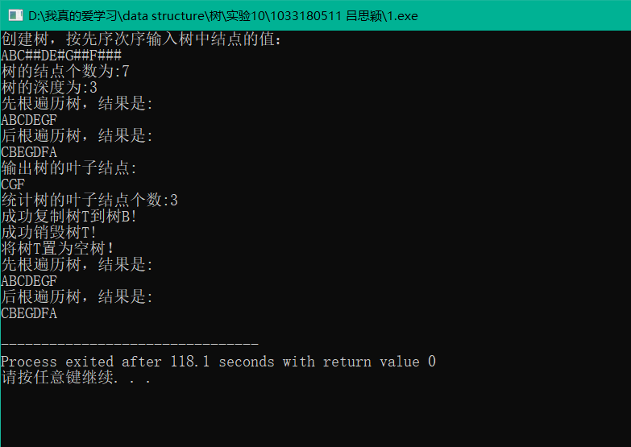
2,
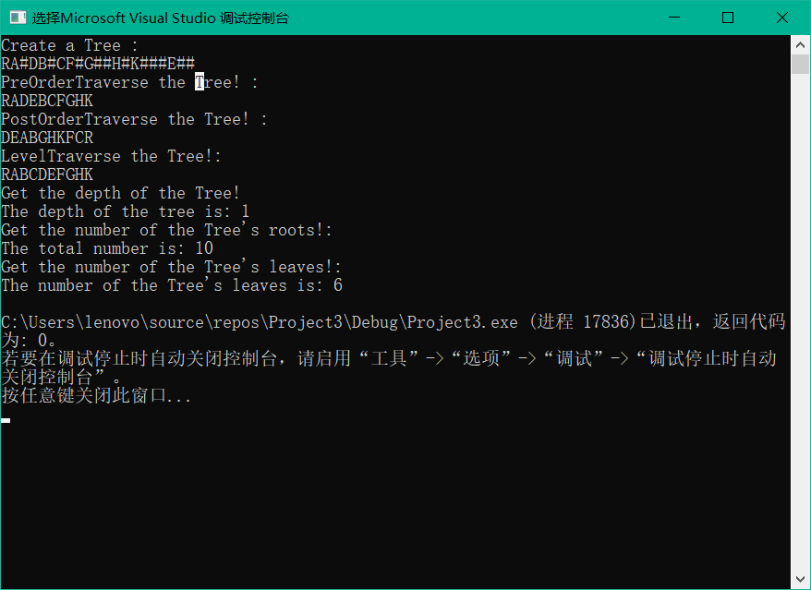

教师评价 | 优 |  | 良 |  | 中 |  | 及格 |  | 不及  格 |  | 教师签名 |  | 日期
江南大学物联网工程学院实验报告

